6-1.HelloBot advance
1.Preparation
1.You should learn about the position of the motors in the body of hellobot；
2.You should learn how to drive the motors with the PCA9685PW.
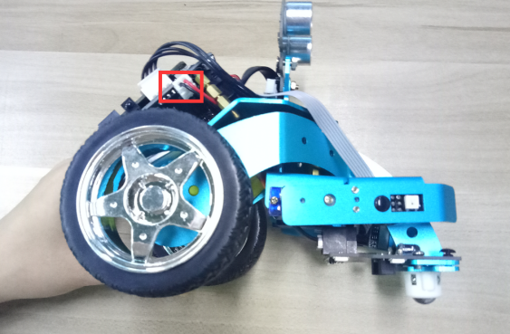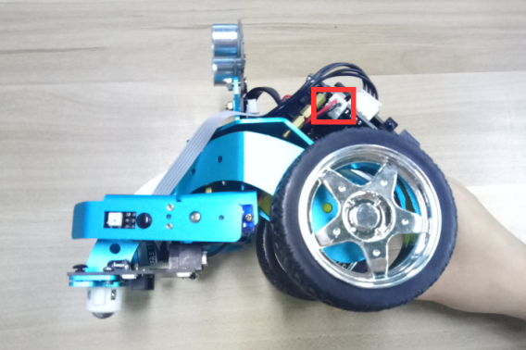
(a)Left motor on the hellobot (b)Right motor on the hellobot
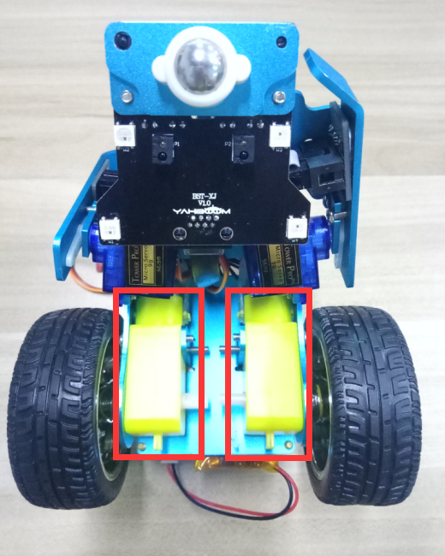
6-1-1 tow motors
The HelloBot robot uses two yellow TT DC gear motors, and the rotation of the motor drives the wheel forward. The motor on the left is connected to the left side of the expansion board, and the motor on the right is connected to the right side of the expansion board.
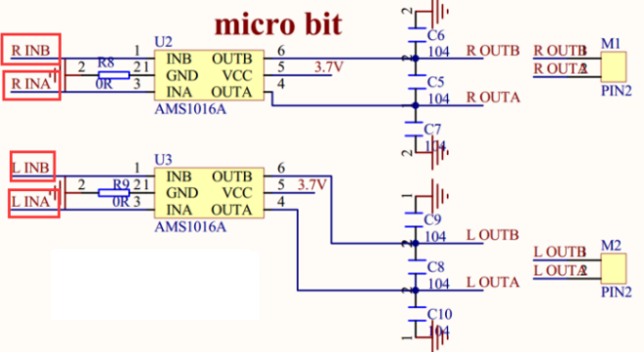
6-1-2 schematic of motor drive
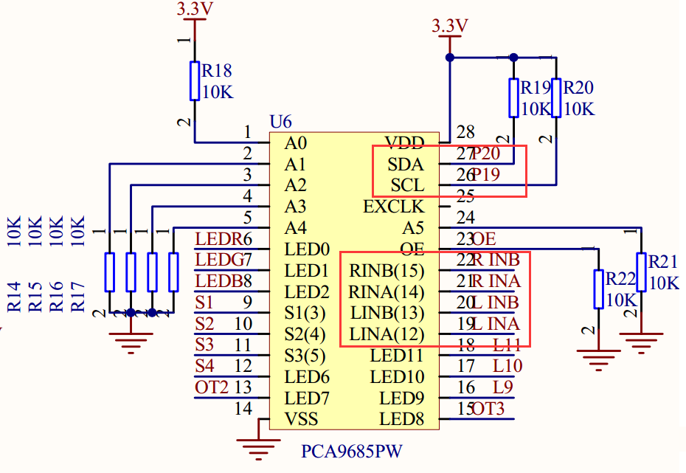
6-1-3 schematic of PCA9685PW

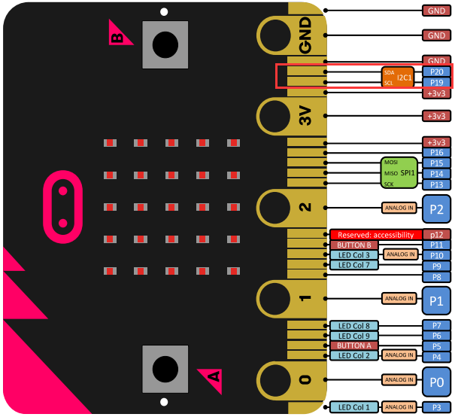
6-1-4 Pins of Micro:bit
From the schematic diagram in P6-1-3,P6-1-4.You can see that tow motors is connected to LINA(12)、LINB(13)、RINA(14)、RINB(15) of PCA9685PW.
PCA9685PW is a 16-bit LED controller with IIC bus interface. Each LED can output 12-bit resolution (4096 levels) fixed-frequency independent PWM.
To advance the robot, it is only necessary to make LINA (12) output high level, LINB (13) output low level, RINA (14) output high level, RINB (15) output low level. PCA9685PW connects micro:bit P19 and P20 pins for I2C communication.
Note:In the bottom layer of the HelloBot package has been set parameter for the user, you can directly drag the car control building blocks.
- Learning goals
In this course, we will learn how to make HelloBot robot advance.
3.Programming
3.1 Programming online
You can enter the URL directly in your browser: http://python.microbit.org/v/1 to enter programming online interface.
3.2 Programming offline
1) You can double-click to use it. As shown in the following figure.

2) After entering the programming interface.
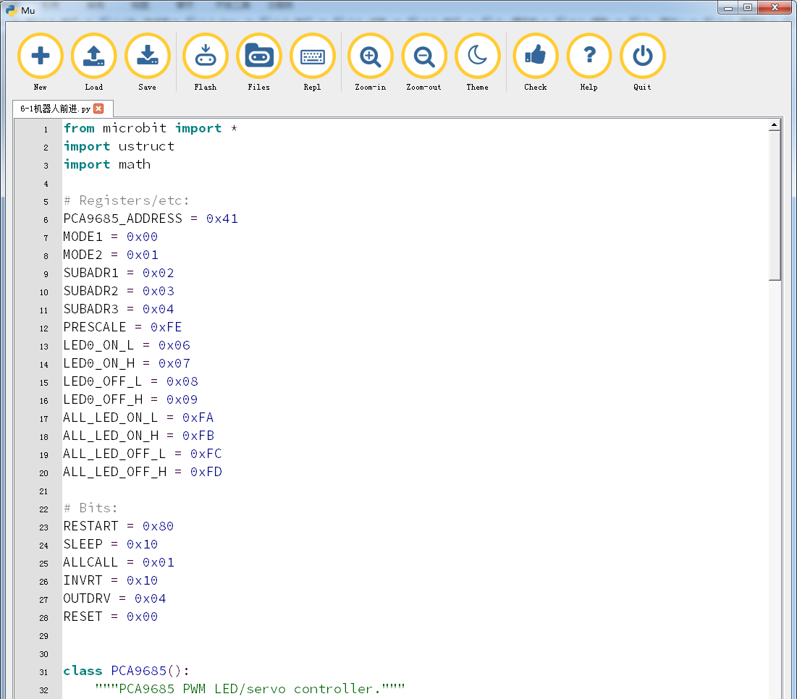
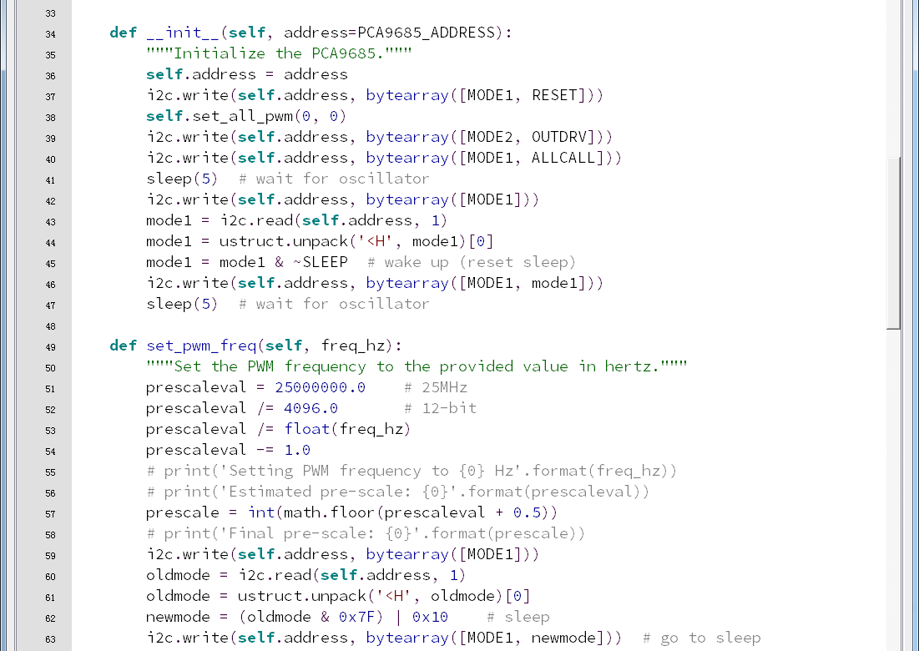
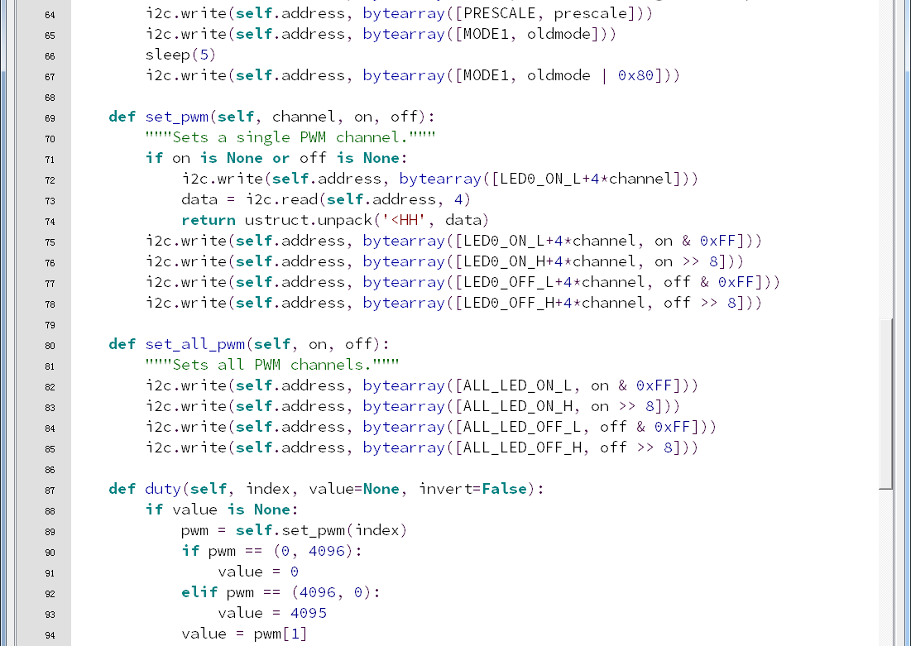
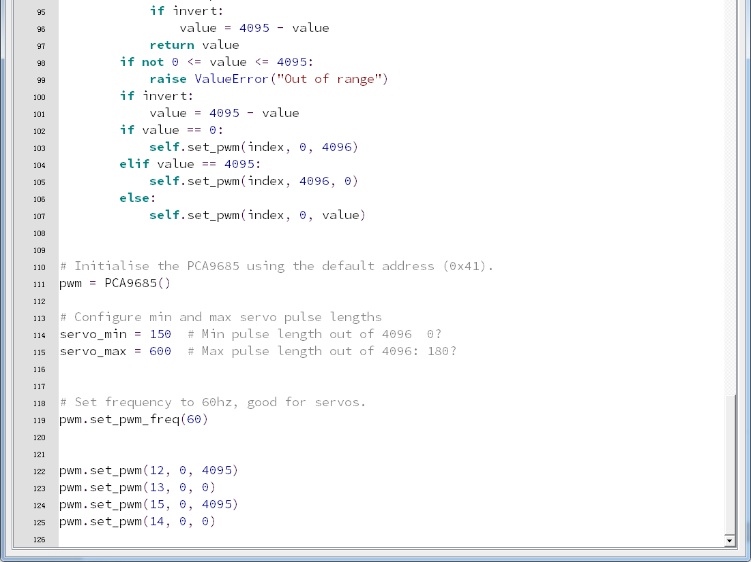
6-1-5
Note:
1 - The capital letter / lowercase letters must be distinguished！
2 - Correct spelling!
3 - Keywords such as # need a space between the content.
4 - The program ends with a blank program.
5 - The block body (such as the body of the while is marked by indentation), compared to the C language, Python completely eliminates the braces (along with the semicolon of the suffix), and uses the indentation structure to represent the relationship. You can only use the Tab key (tabulation key) for indentation.

4.Download programming
You need to make sure that the micro:bit development board is connected to the computer. Then you should click on the download in the lower left corner as shown in P 6-1-6 to download the program to micro:bit.
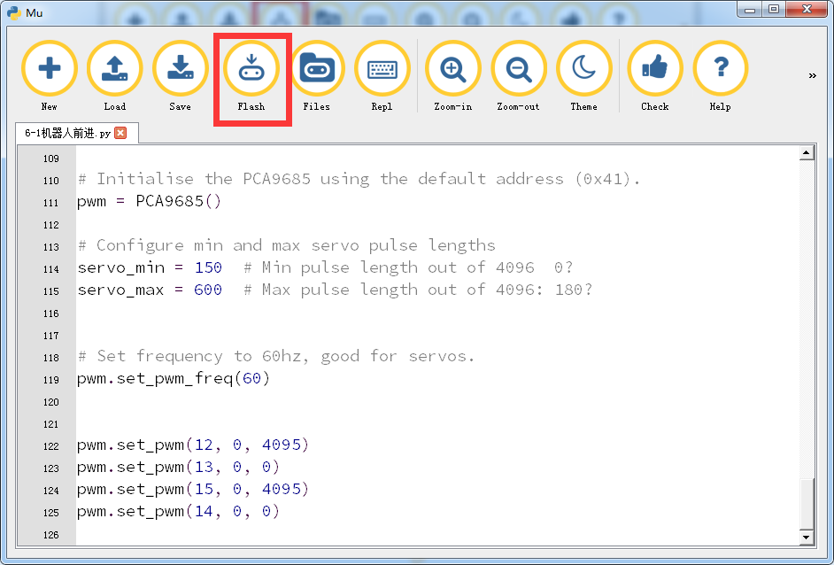
6-1-6
5.Phenomenon
After the code is uploaded. The car will advance.
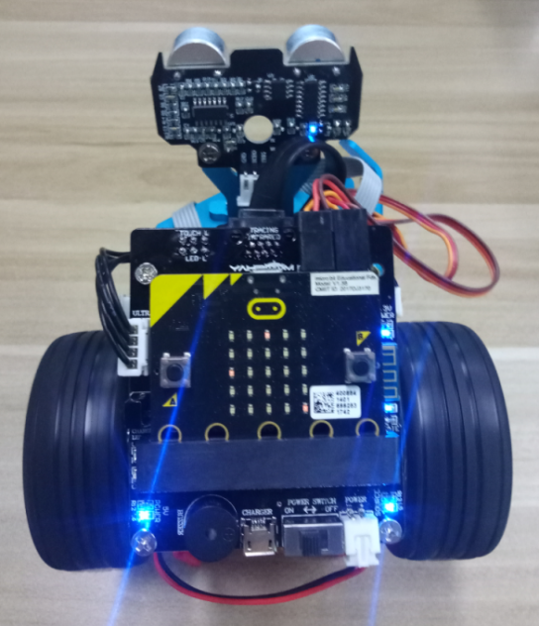
6-1-7

